Channel Processing System

Laura Jones 21/11/2021

The application for this use case was created in C#, using .NET for a Windows environment. The aim of this application is to take in user inputs for values for parameters m and c and to use a user defined input in the form of a comma-separated text file for the recorded values of X.

# Functional Specification

The requirements for this application have been broken down into must and won’t requirements based on the brief given.

|  |  |  |
| --- | --- | --- |
| Requirement ID | Category | Description |
| Fun-M-01 | MUST | Must take in user submitted values for m and c |
| Fun-M-02 | MUST | Must allow user to select a text file with X-data in |
| Fun-M-03 | MUST | Must calculate and display value of b to user |
| Fun-M-04 | MUST | Must be easy to use for end user |
| Fun-M-05 | MUST | Must allow repeated use |
| Fun-M-06 | MUST | Must be easily maintainable should functions change. |
| Fun-M-07 | MUST | Must give correct output value b for input values of X |

|  |  |  |
| --- | --- | --- |
| Requirement ID | Category | Description |
| Fun-W-01 | WON’T | Will not be able to process user defined functions |
| Fun-W-02 | WON’T | Will not showcase historic or re-runs of the calculation |
| Fun-W-03 | WON’T | Will not need to be web-accessible |

From these requirements, a desktop application was deemed the most appropriate, however if the requirements for the application change then this would change. For example, if the application was required to be web-accessible or accessible on a server, then using a server with a web-based front end may be more suitable.

# Mathematical Backbone

The main purpose for this application is the processing of the channel inputs in order to calculate and display the metric. Using the functions provided, the following was derived and used for this task:

Function 1:

$$Y=mX+c$$

Function 2:

$$B=A+Y \\ b=mean(B)$$

Function 3:

$$A=\frac{1}{X}$$

Function 4:

$$C=X+b$$

In order to calculate metric b, a function in the form of F(X) was required. This was achieved by substitution using the provided functions:

Combining Function 1 and 2:

$$B=A+mX+c$$

Substitute using function 3:

$$B=\frac{1}{X}+mX+c$$

As m and c are known parameters, function 4 can be used as a test function after calculating b.

During the development of the application it was assumed that C was a function of X and that m and c are known but not necessarily constant for every run of the calculation and so a user input option was needed.

From this derivation, the value of C should be approximately constant with respect to X and when plotted should form a straight line.

# Testing

The mathematical nature of the use case for this application requires testing to ensure the output value can be trusted. This would be implemented using unit testing if there were a large value of calculated variables, however due to the simple nature of this application, this can be done by hand.

Taking the provided input file (channels.txt), the calculation for this data was done using excel as this allows automation of the calculation. This gave the value of 6.269852167 for b, which is equal to the value calculated using the application. (The manual testing document can be seen in the Docs folder provided).

During the development, the values were printed to console to check that the calculations had been done correctly, this has been removed in the finished version.

### Functional Testing

To test the application against the defined requirements, a 3rd party was asked to complete the testing - in this case a non-developer friend was asked to use the application for intended purpose.

|  |  |  |  |  |
| --- | --- | --- | --- | --- |
| Requirement ID | Category | Description | Result |  |
| Fun-M-01 | MUST | Must take in user submitted values for m and c | PASS |  |
| Fun-M-02 | MUST | Must allow user to select a text file with X-data in | PASS |  |
| Fun-M-03 | MUST | Must calculate and display value of b to user | PASS |  |
| Fun-M-04 | MUST | Must be easy to use for end user | PASS | Non-developer independent test |
| Fun-M-05 | MUST | Must allow repeated use | PASS |  |
| Fun-M-06 | MUST | Must be easily maintainable should functions change. | FAIL | Non-developer independent test |
| Fun-M-07 | MUST | Must give correct output value b for input values of X | PASS |  |

Fun-M-06 was not passed, this is due to the independent tester not feeling comfortable being able to change the code. This has been addressed by adding to the ‘use of the application’ section.

# Use of the Application

This application will calculate the value of metric ‘b’, this has been set to stay at the accuracy of the input data (15 dp), however this can be easily changed to be only as precise as the least precise parameter (in this case that would be 1dp from the provided m and c values). This can be set in the code on line 53 in MainWindow.cs.

The application will load after the .exe file is double clicked. The interface for the application is simple and is shown below:

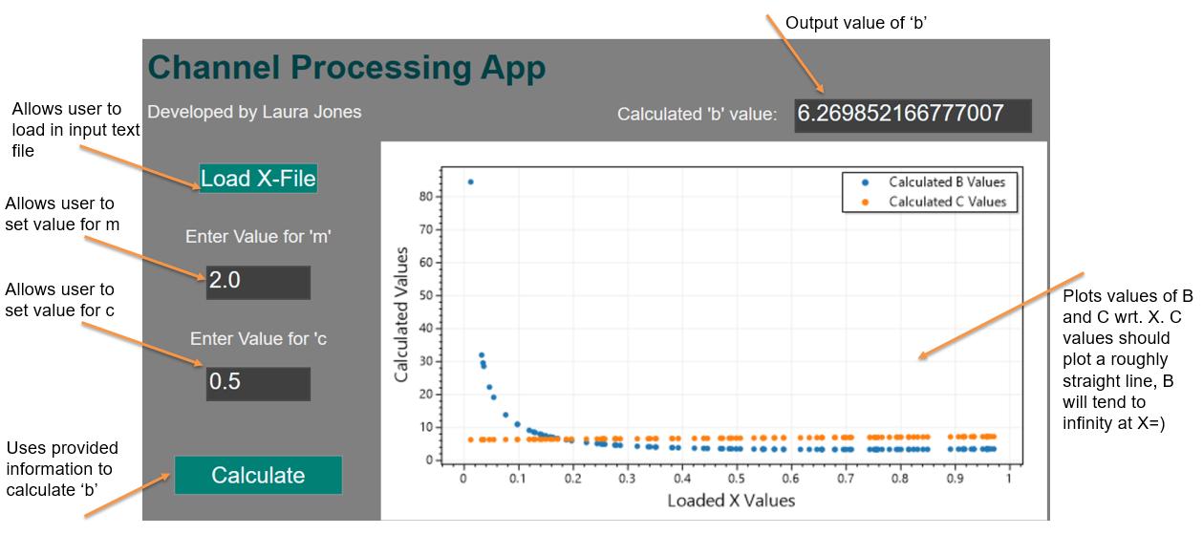

Usage steps:

1. Click the X-File button and select the .txt to be used
2. Optionally set the value of m and c
3. Click the calculate button
4. Optionally - if the graph does not update straight away, re-size the window to force refresh

The calculated value of b is shown along with a plot showing how the value of B changes with X for the given parameters.

If the relationship between the functions changes, the underlying logic can be modified as shown below. This can be done by re-defining the function derived earlier. UtilFunctions.ProcessB contains the mathematical processing of B. The calculation of b from B is handled in UtilFunctions.CalcB and is rounded to 15 dp given in the input file. To calculate b, the values of B are summed and the total divided by the number of values to give the mean value.

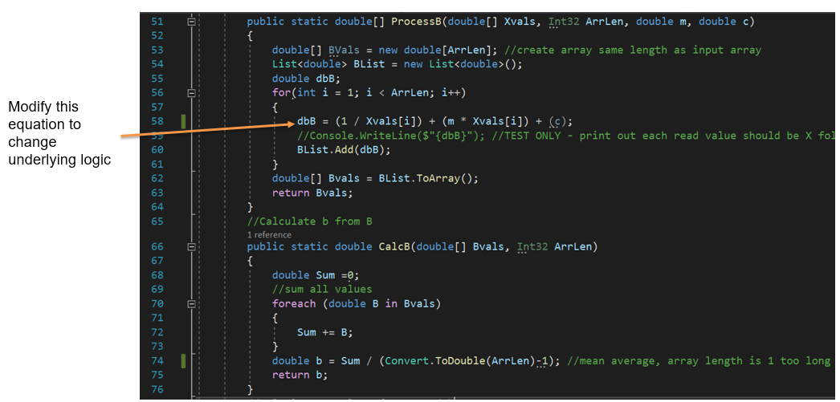

# Further Development

Further development of the application could include:

* For easier sharing, have the application web-based
* Add additional function for plotting only if required
* Add option to export plot (eg as PNG, PDF etc.) and calculated data as text files
* Add slider to dynamically change the values of m and c
* In legend, add the m and c values to make the sequential runs more obvious
* Add the option for calculating multiple .txt files